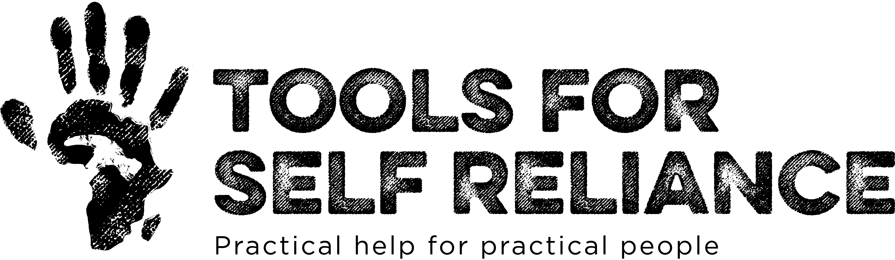

Leaving a gift in your will
A gift in your will is a wonderful way to leave a legacy for future generations. By supporting Tools for Self Reliance in this way, you can help people build sustainable livelihoods, and change their lives, for many years to come.
There are several ways to leave a gift, and you can add a legacy to an existing will too. Listed below are the types of gift:
- A residuary legacy is the whole or a share of the remainder of your estate once all your other costs and gifts have been deducted.

- A pecuniary legacy is a gift of a specific amount, rather than a percentage share.

- A specific item – such as jewellery or equipment.

It is important to ensure that you include our name – Tools for Self Reliance – and our Charity Number, 280437 in the wording of your will. However you choose to support us, you will know that your gift will be making a real difference to people’s lives.

For more information about leaving a legacy, please contact Jemma Chambers, Head of Fundraising, on 023 80869697. You can also email her on jemma@tfsr.org or write to her at Tools for Self Reliance, Ringwood Road, Netley Marsh, Hampshire, SO40 7GY

